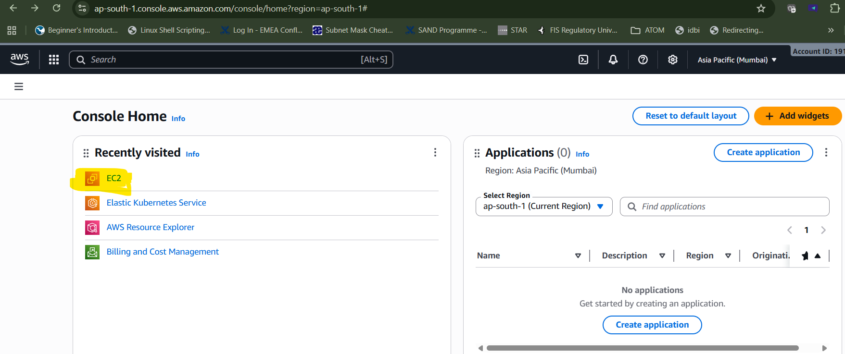

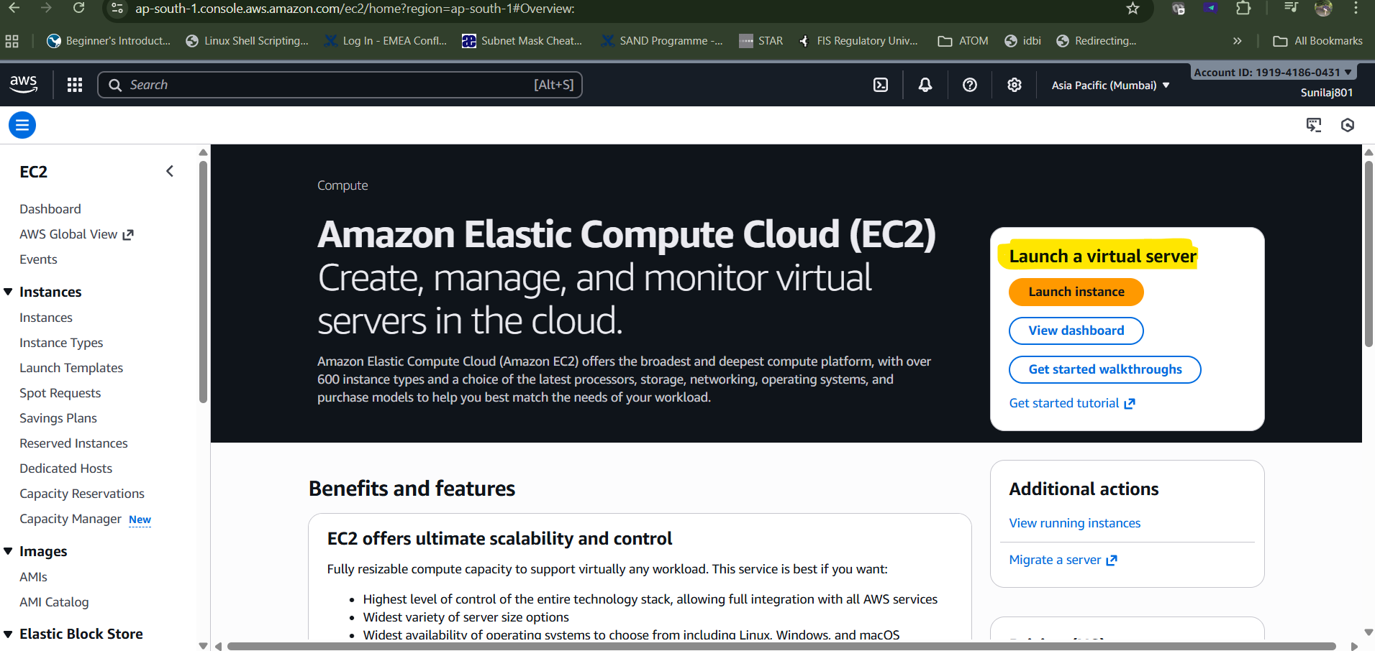

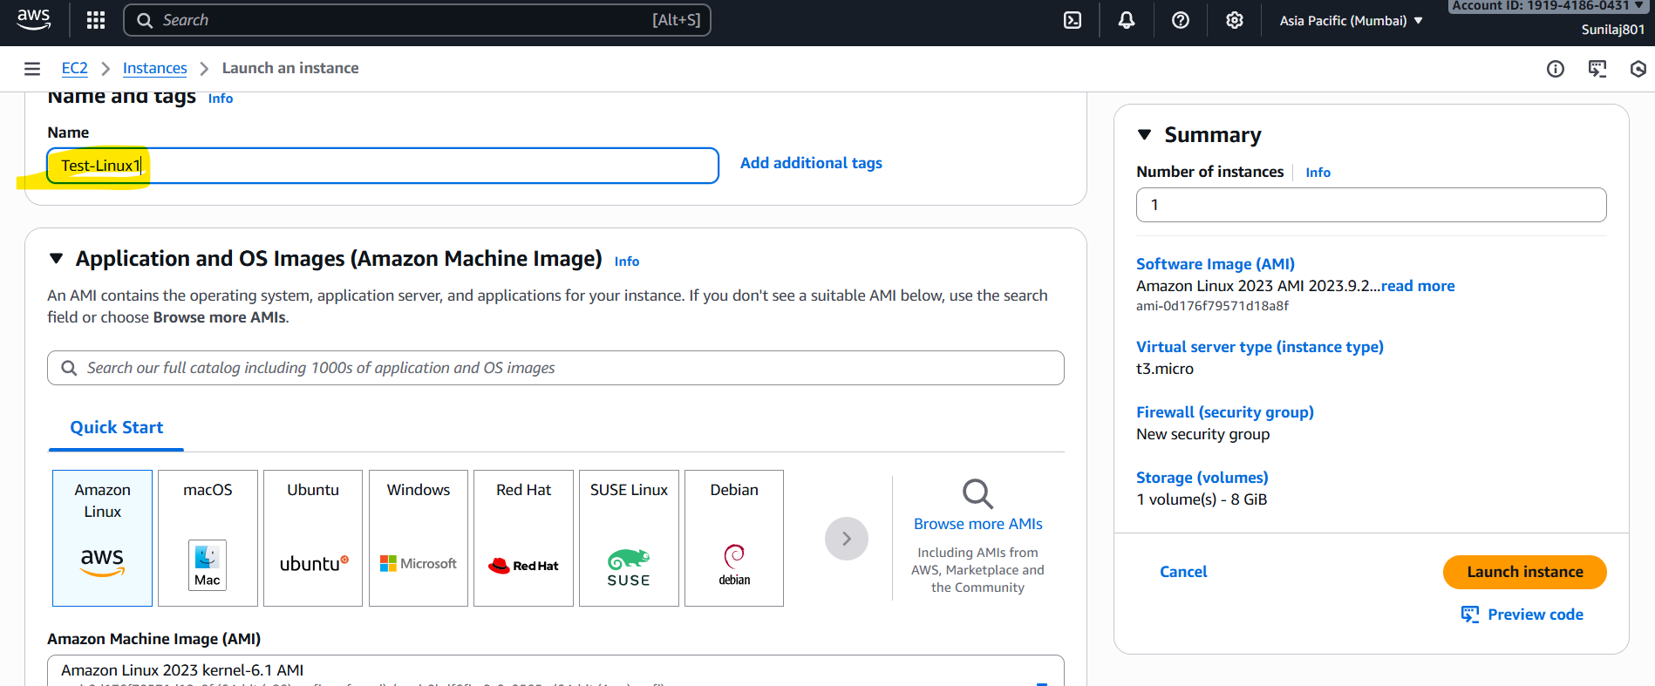

I created new key pair with ” .ppk For use with PuTTY” save the file in your local.

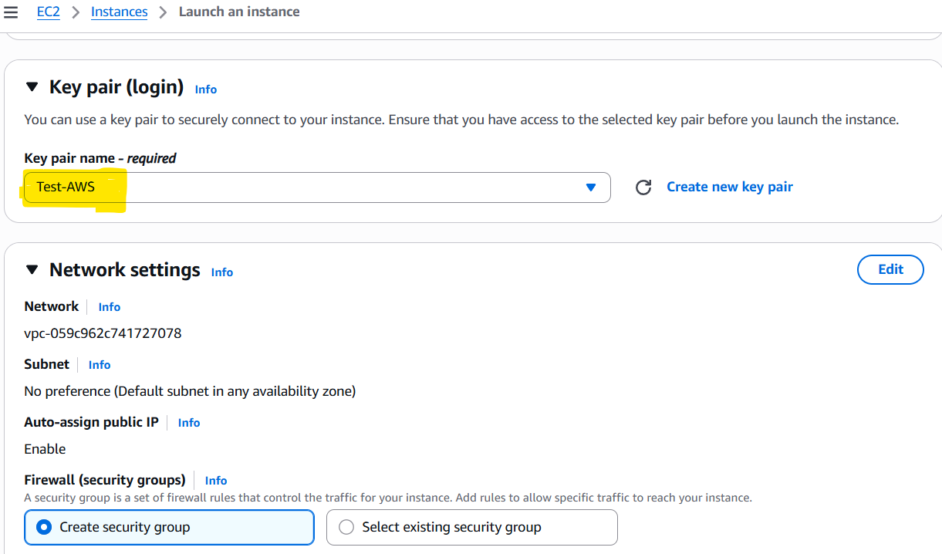

#!bin/bash
echo "Red9SysTech: Starting Bootstrap script for Apache web Server"
yum update -y
yum install -y httpd
systemctl start httpd
systemctl enable httpd
echo "<h1>Red9SysTech - EC2 Web Server Deployed Successfully via Bootstrap</h1>" > /var/www/html/index.html

Launch instance

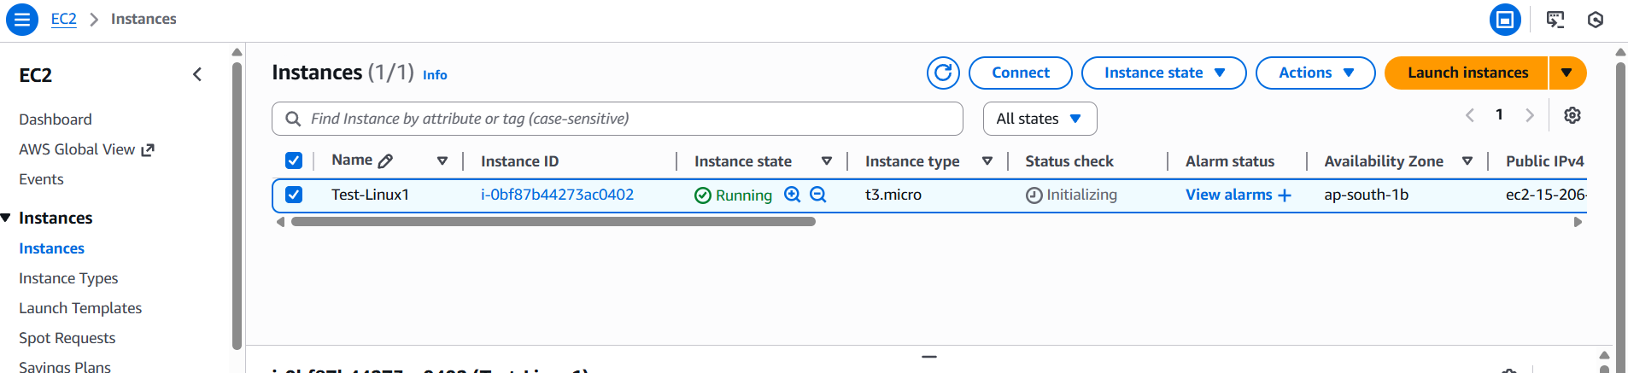

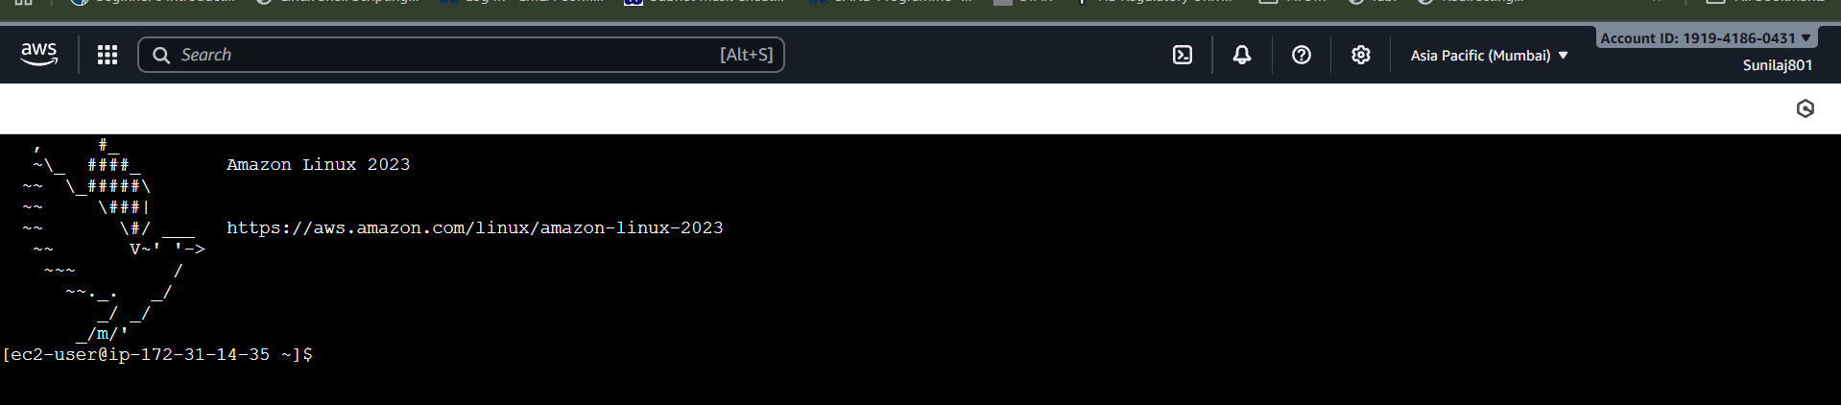

Connected via putty with the ssh key. User “ec2-user”

